**UCS 2611 Internet Programming Lab**

**Exercise 11. Online Shopping Application using ReactJS**

Develop an Online Shopping Application to enable the users to order the products. [CO2, K3]

This Application contains necessary components namely, *App, Show, and Cart*. The *App* Component ensures maintaining the data related to products and the necessary functions. *Show* Component helps to show the details of the products to the users based on the input. *Cart* component is responsible for maintaining the data the user wishes to purchase.

Application has the following:

* The parent component App hosts the other components.
* Maintain the details of the products in the App component
* Define necessary functionalities in the required components to display the shopping cart application looks like below:

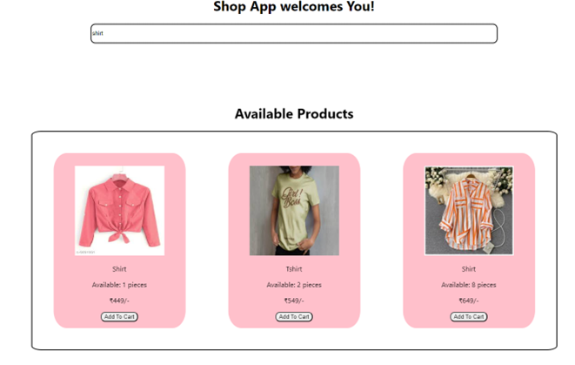



Best Practices to be followed:

1. Design before coding
2. Incremental coding
3. Usage of proper naming convention
4. Usage of Comments to the code
5. Indentation of code